Pass for level 21: IFekPyrQXftziDEsUr3x21sYuahypdgJ

Step 1: Login

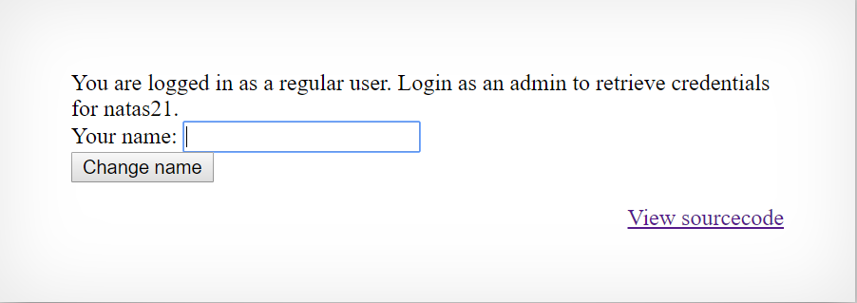

Step 2:View source code

We will start with:

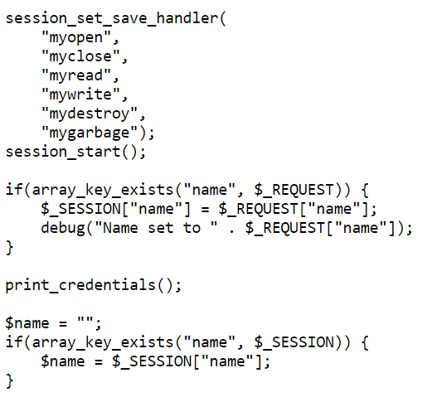

It is tell us that we can see what happened with the session handlers and the ones that really changed was:

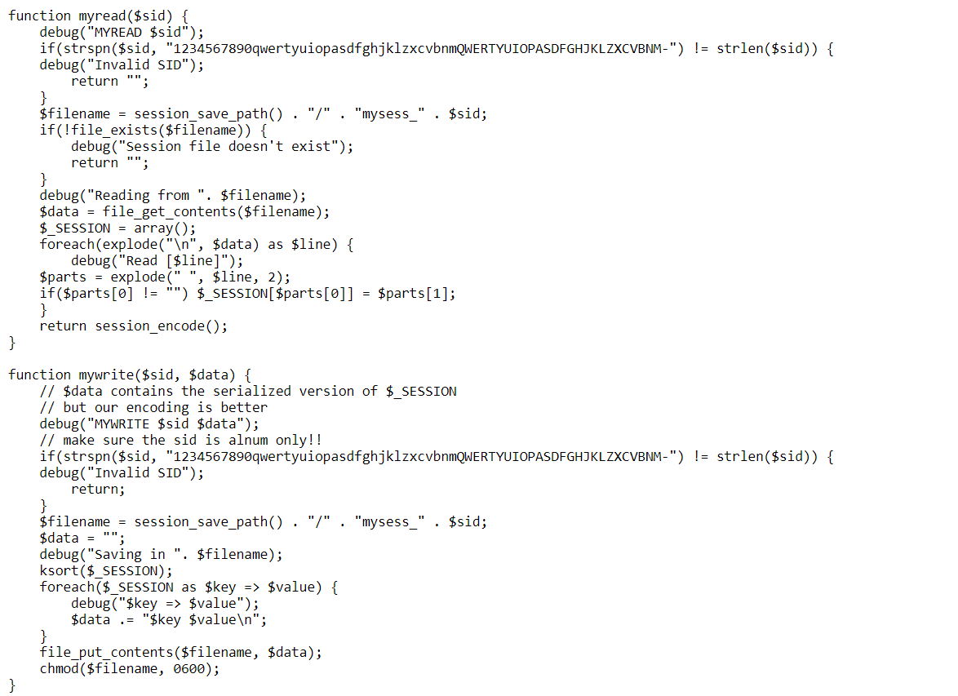

There is write and read functions and lets play with that.

The read function reading from the file as key value store by lines.

The write function simply put the content in the file.

Step 3:

Because of :

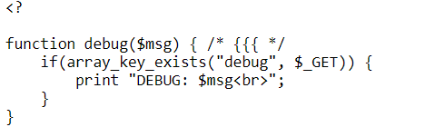

I can use ?debug=true and see the results.

Step 4:Running the same get requests twice

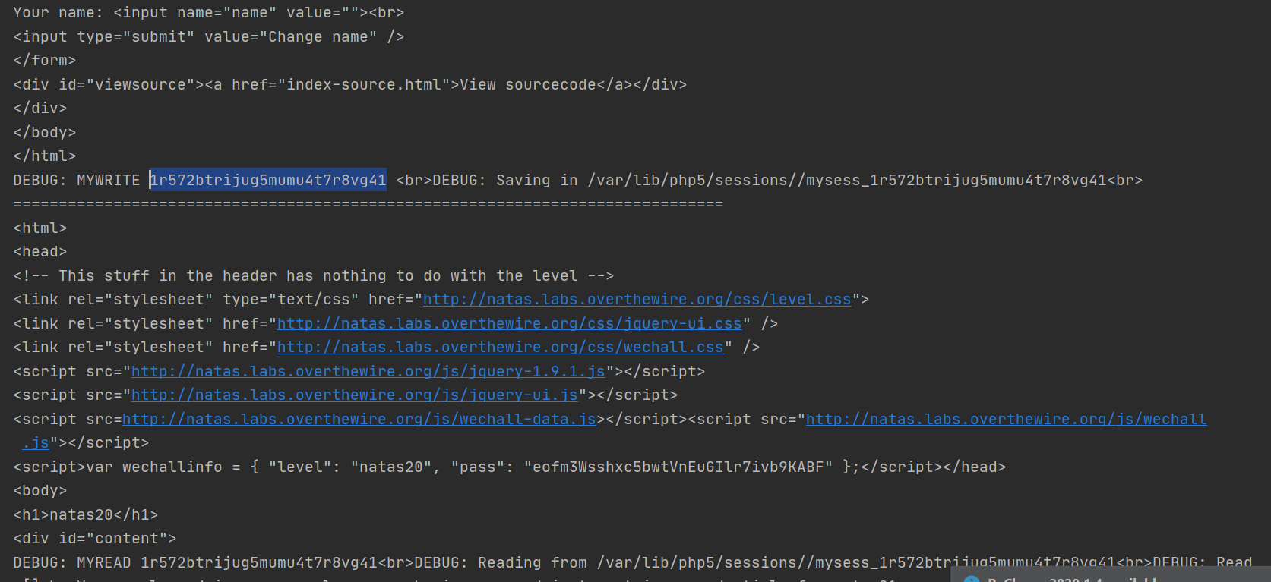

The same code.

Step 5:in the read it split the information line by line via \n and use key value with separate space Hence we can inject "admin 1" in this way.

We will post username = "something\nadmin 1"

And then Get requests again so it should read "admin 1"

Results:

